Experiment 1

Aim: Introduction and overview of cloud computing with a case study on Eucalyptus Cloud.

Theory:
The Origin Of Cloud Computing:
Cloud computing started in the 1960s when people began sharing and using computing resources from afar. The term "cloud computing" became popular in the early 2000s to describe getting computer services over the internet. Amazon Web Services (AWS) played a big role by introducing Elastic Compute Cloud (EC2) in 2006. This made it easy to use and scale computing power when needed. This changed how we do IT, moving from having our own computers to using virtual ones online. Today, big companies like AWS, Microsoft Azure, and Google Cloud lead the way in cloud computing.
Cloud Cube Model:
The Cloud Cube Model in cloud computing is like a guide to understand different types of cloud services. It looks at three main things: how services are provided (like IaaS, PaaS, SaaS), where they are available (Public, Private, Hybrid), and essential features they have (like being easy to use, accessible from anywhere, sharing resources, easily adjustable, and pay-as-you-go). This model helps people figure out which cloud setup is best for them by considering factors such as control, scalability, and cost.
NIST Model:
NIST, or the National Institute of Standards and Technology, is like a guide for cloud computing. It sets important rules about how cloud services should work. NIST focuses on things like making sure cloud services can grow easily, be accessed from anywhere, and use resources efficiently. The guidelines also help keep cloud systems secure and easy to use. These rules are not just for one place but are used worldwide, making sure everyone understands and follows the same standards for cloud computing. Following NIST's guide helps organizations choose and use cloud services in a way that is reliable and consistent.
Characteristics of Cloud:
Cloud computing lets you use computer stuff like storage and processing power over the internet whenever you need it. It's like a pay-as-you-go service, so you only pay for what you use. You can access your data and apps from anywhere. It's reliable because it has backup systems in case something goes wrong. Your data is kept safe with encryption and other security measures. Many people can use the same computer resources at the same time. The system takes care of updates and maintenance automatically. It's good for working together on projects, and it's designed to be energy-efficient, helping the environment.

Different Deployment Models:
Cloud computing comes in different types: public (shared by everyone), private (just for one group), hybrid (mix of public and private), and community (shared by a specific group). Public clouds, like AWS and Google Cloud, are good for flexibility and saving money. Private clouds offer more control but cost more. Hybrid clouds use both on-site and cloud resources. Community clouds are for specific groups. Choosing the right type depends on needs like security and cost.
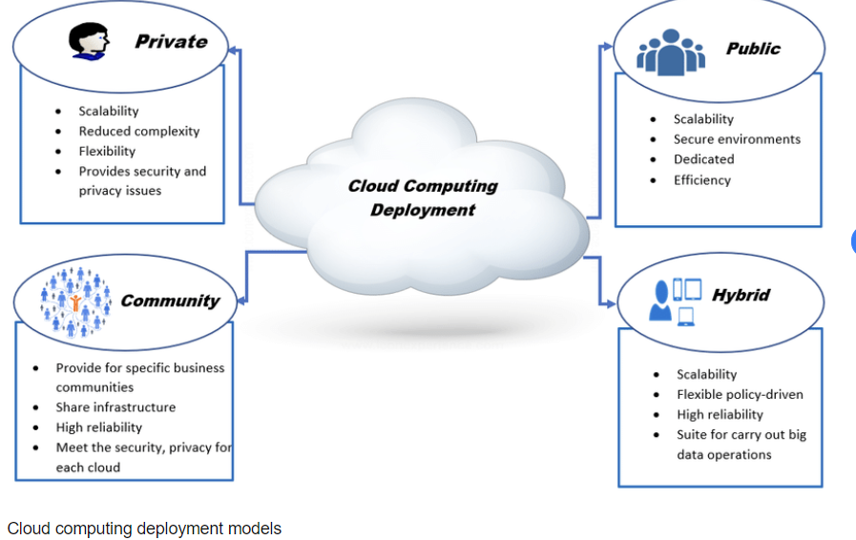
Service Models:
Cloud computing has various service models. Infrastructure as a Service (IaaS) offers virtualized resources. Platform as a Service (PaaS) aids developers in building and managing applications. Software as a Service (SaaS) delivers software via the internet, eliminating local installations. Function as a Service (FaaS) enables serverless computing for running individual functions. Desktop as a Service (DaaS) provides remote access to virtual desktops. Backend as a Service (BaaS) simplifies app development with pre-built services. Storage as a Service (STaaS) offers scalable cloud-based storage. Database as a Service (DBaaS) manages databases, including backups and scaling. Network as a Service (NaaS) enhances scalability with cloud-based networking. Business Process as a Service (BPaaS) outsources specific business functions using cloud solutions.

Advantages and Disadvantages:
Advantages:
- Scalability enables seamless resource adjustment.
- Cost efficiency is achieved through a pay-as-you-go model.
- Accessibility is enhanced with convenient remote collaboration.
- Reliability is assured with redundant systems ensuring continuous access.
- Automatic updates are managed by providers, ensuring software currency.
Disadvantages:
- Security concerns arise, posing risks of data breaches and unauthorized access.
- Dependency on third-party providers may impact critical service reliability.
- Downtime can disrupt operations and compromise accessibility.
- Limited customization options restrict configuring and optimizing infrastructure.
- Data privacy is a concern, especially regarding sensitive information storage and handling.

Conclusion:-
In summary, looking into cloud computing and studying Eucalyptus Cloud shows how much it changes the way we use computers nowadays. The cloud cube model and NIST model help us understand how cloud systems are set up. Even though cloud computing has many benefits, it's important for companies to think about the downsides and make sure they have strong security. The Eucalyptus Cloud case study is a good example of how free-to-use solutions can help shape and personalize cloud services, allowing businesses to adjust and do well in the digital age.

